**WRONG**

<link href="css/bootstrap.min.css" rel="stylesheet">

<!-- Custom CSS -->

**<link href="css/simple-sidebar.css" rel="stylesheet">**

**<link href="css/bootstrap-combined.min.css" rel="stylesheet" />**

**<link href="css/style.css" rel="stylesheet" />**

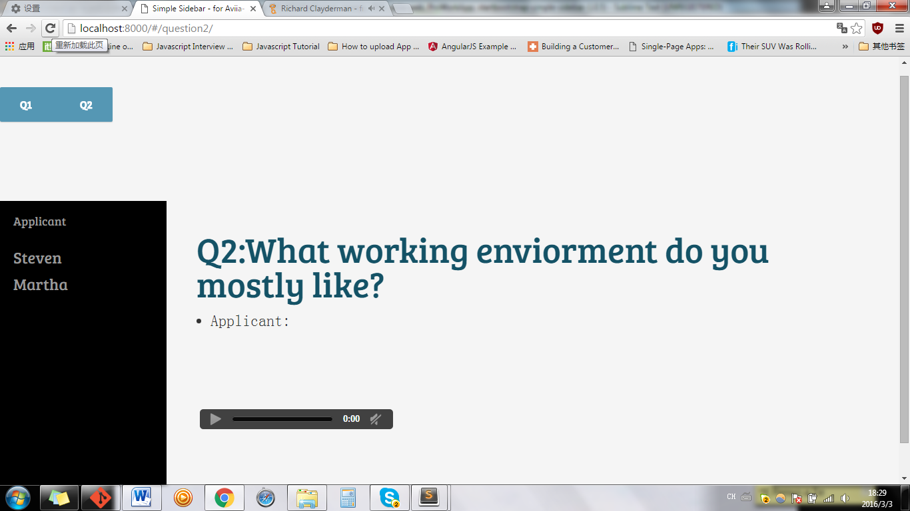

**RIGHT**

<link href="css/bootstrap.min.css" rel="stylesheet">

<!-- Custom CSS -->

**<link href="css/simple-sidebar.css" rel="stylesheet">**

**<link href="css/bootstrap-combined.min.css" rel="stylesheet" />**

